**Lanthanide luminescent bioprobes for two-photon microscopy: Towards Circularly Polarized Luminescence.**

**A.Roux,1,3 N. Gillet,1 F. Riobé,1 S. Engilberge,2 E. Girard,2 O. Maury1**

*1- Laboratoire de Chimie de l’ENS Lyon, 07*

*2- Institut de Biologie Structurale, 71 avenue des Martyrs, 38000 Grenoble*

*3- Polyvalan Company 46 allée d’Italie, 69364, Lyon Cedex 07*

Introduction of lanthanide complexes in protein crystals is an efficient approach for the determination of protein structures with high resolution using anomalous-based X-ray diffraction techniques.[1] Previous results using tris-dipicolinate lanthanide complexes have shown that such complexes can also play an active role in the organization of the proteins at the solid state through a non-covalent binding mode, especially with arginine residues.[2]

The new generation of luminescent lanthanide complexes, called *crystallophore* and based on a triazacyclononane (TACN) platform will be described. It presents additional properties of nucleation and crystallization of biological macromolecules and conserve its phasing and luminescence properties.[3] Such entities are able to induce new crystallization conditions and/or to improve the crystal quality of derived crystals for numerous proteins. These phenomena and the possible mechanisms implied will be presented. In particular, we will focus on the studies of the supramolecular interactions of these lanthanide complexes with proteins in solution and in the solid state opening new insight in protein crystallization mechanism.

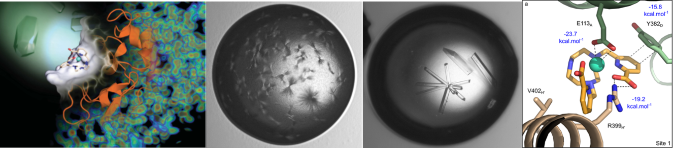

Figure. Crystals of PB6 protein: classical conditions (*on left*); with Ln-complex (*on right*), interaction in the solid state.

References

[1] G. Pompidor, A. D’Aléo, J. Vicat, L. Toupet, N. Giraud, R. Kahn, O. Maury, *Angew. Chem. Int. Ed.*, **2008**, *47*, 3388

[2] E. Dumont, G. Pompidor, A. D'Aléo, J. Vicat, L. Toupet, R. Kahn, E. Girard, O. Maury, N. Giraud *PhysChemChemPhys* **2013**, *15*, 18235-18242

[3] a) S. Engilberge, F. Riobé, S. Di Pietro, L. Lassalle, N. Coquelle, C. Arnaud, D. Madern, C. Breyton, O. Maury, E. Girard *Chem. Science*. **2017**, *8*, 5909-5917; b) S. Engilberge, F. Riobé, T. Wagner, S. Di Pietro, C. Breyton, B. Franzetti, S. Shima, E. Girard, E. Dumont, O. Maury *Chem. Eur. J.* **2018**, *24*, 9739-9746.